https://docs.google.com/document/d/1ztLa3XYOL9QSxY_Td3-fzoqxOTCDFvmnDyt-KBjzAvo/edit?usp=sharing
Repo- https://github.com/bnbishnu2000-hub/Jenkins-task-2.git
EC2 is running
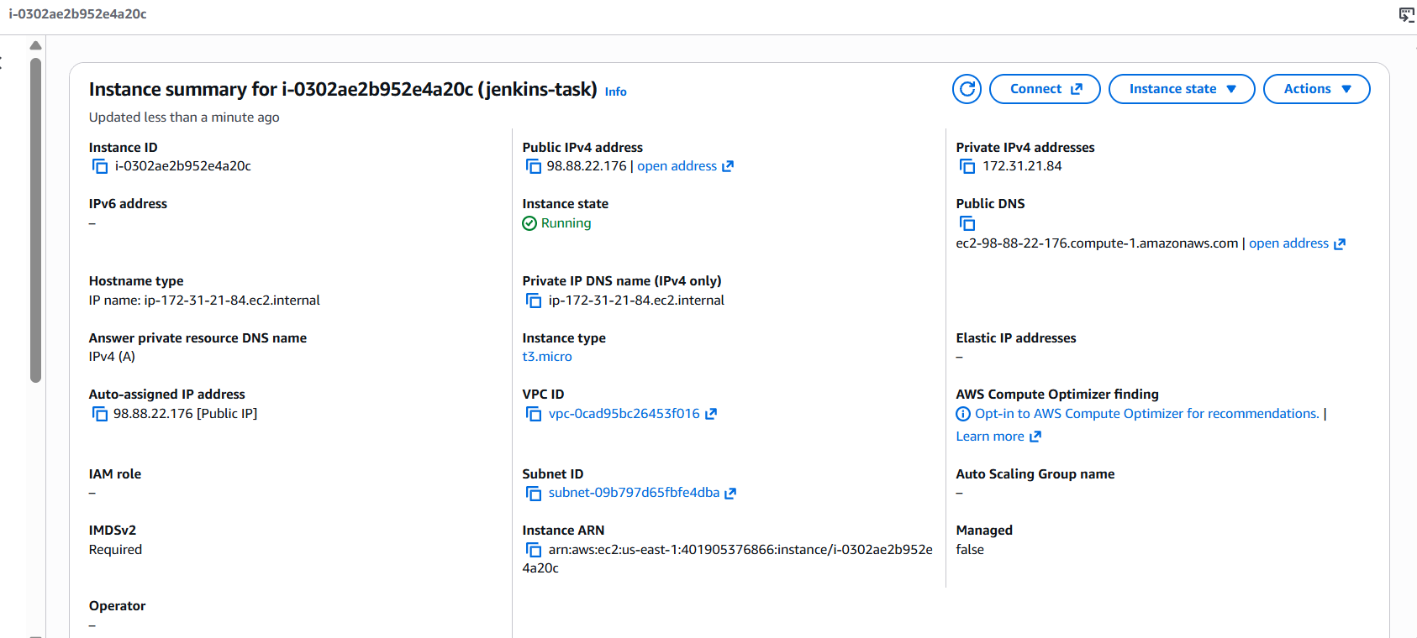Git
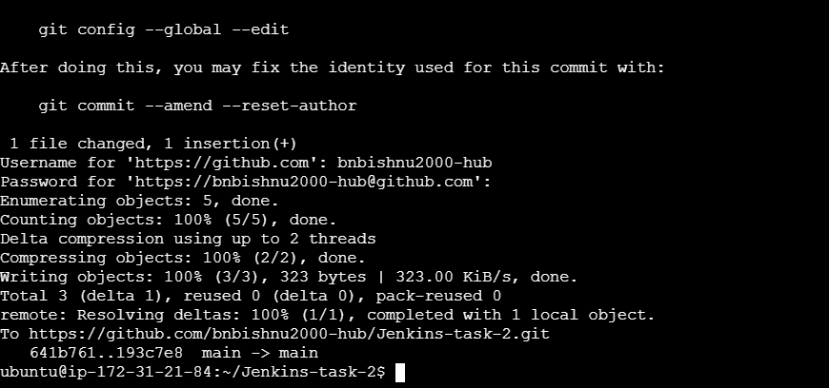
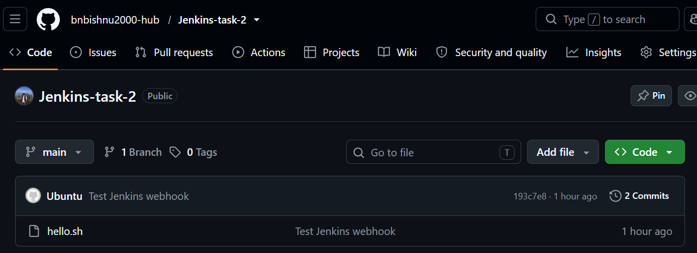
Jenkins
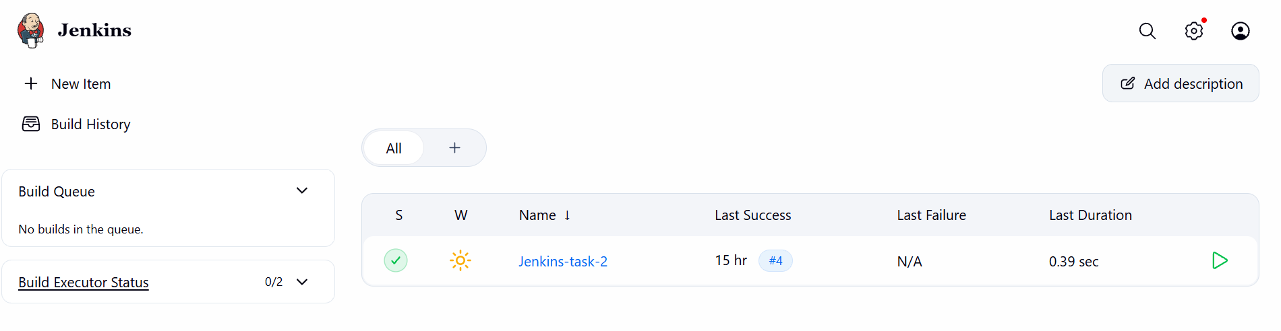
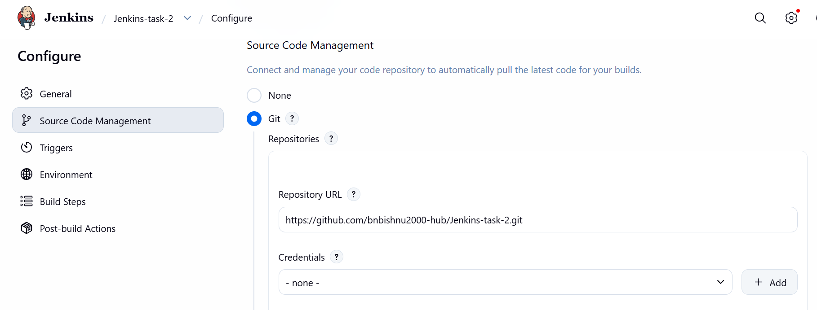
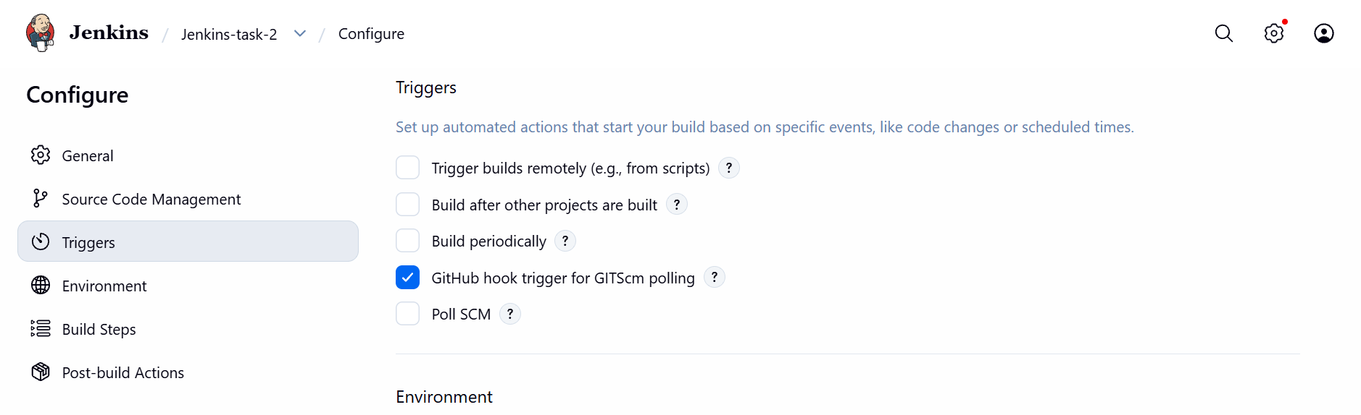
Git Hub webhook
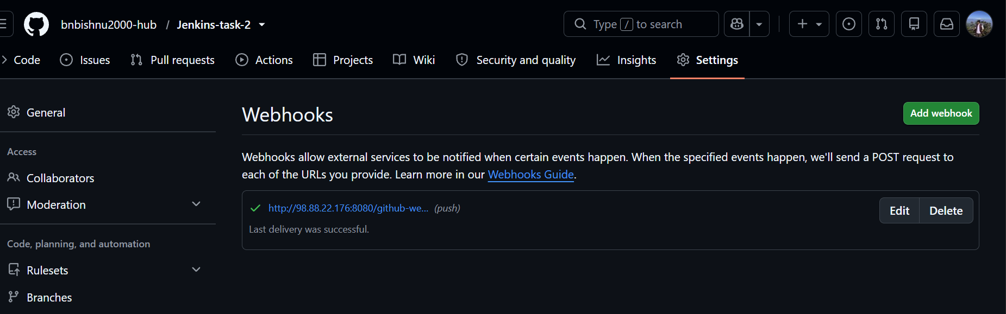

Build success
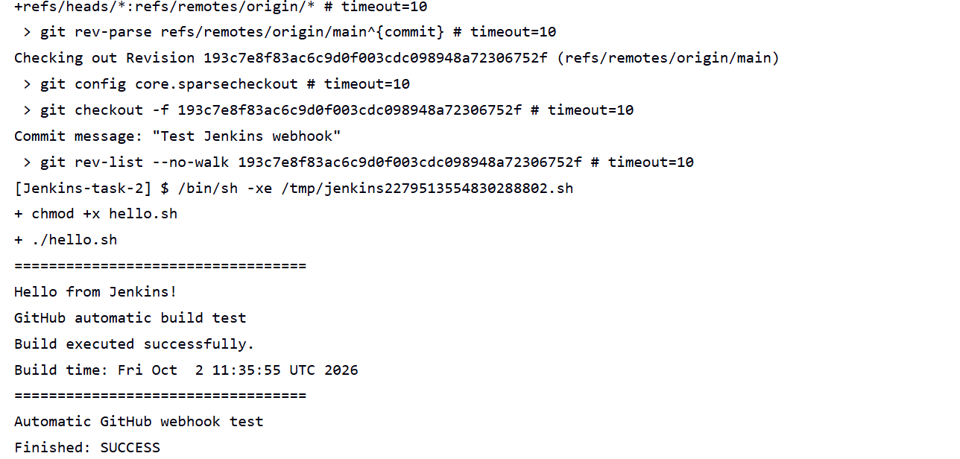
Email setup
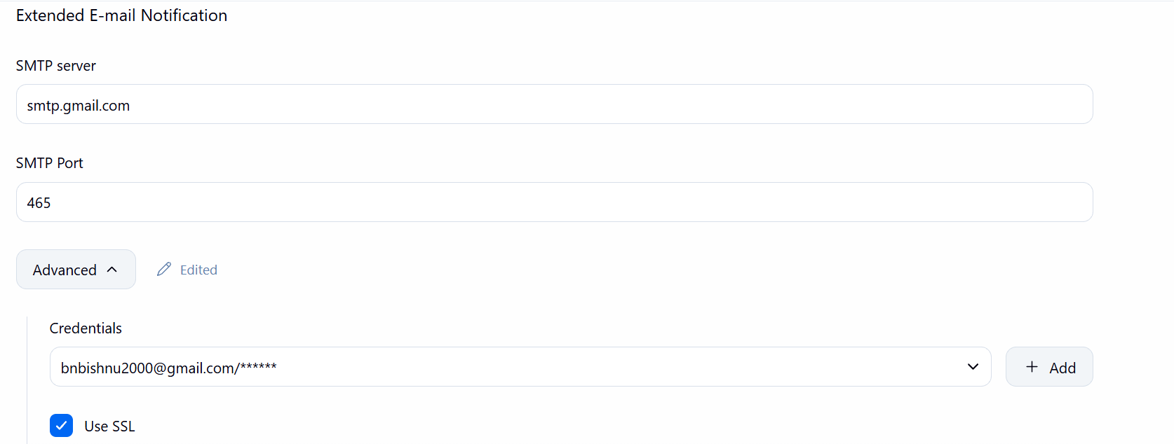
Email Notification
